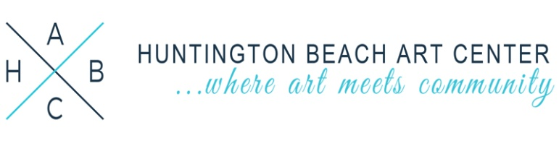
FOR IMMEDIATE RELEASE:
September 10, 2018

The Huntington Beach Art Center Presents

Shines Through
September 22 – October 27
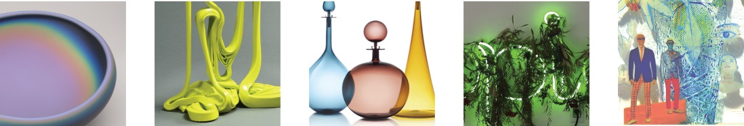
Images from left to right: Katherine Gray, Greg Price, Joe Cariati, Michael Hernandez, Susan Stinsmuehlen-Amend

Huntington Beach, CA – The Huntington Beach Art Center (HBAC) is proud to present the third installment of its 2018 contemporary series: “The Power of Pigment: A Celebration of Color.” Shines Through explores contemporary glass works featuring 33 established and emerging glass artists. Curated by Hiromi Takizawa, the exhibition includes 2D, 3D, and installation works. The Public Opening Reception is September 22, 2018 from 6:30 to 9:00 pm.

Surveying contemporary Southern California glass artworks, Takizawa, a recognized and accomplished contemporary glass artist, will showcase the new artistic practices and the changes within the medium since its inception in Southern California. She states that, “The American glass studio movement started in the late 1960s and was the first movement where artists started using glass as an artistic medium. This show focuses on contemporary glass works and is a celebration and reflection of what's happening after 55 years of the glass movement in the Southern California region.” Furthermore, Takizawa will delve into the current practices by showcasing a wide range of glass working such as glassblowing, glass casting, flame working, kiln forming, painting on glass, neon, and mixed media.

The intention of the exhibition is to explore and examine glass as an artistic material to create extraordinary and unique fine artwork driven by process, materiality, and concept. This will be the first glass exhibition presented by the Huntington Beach Art Center and for Takizawa, this is a reflection of her life’s work and passion. She states: “There is no other artistic material that can produce the same results as working in glass. Glass can be transparent, fluid, fragile, magnifying, structural, sculptural, functional, stained, designed, as well as being abstracted.” The exhibition opens later this month and will run until late October.

The Huntington Beach Art Center (HBAC) is a community arts and cultural center. Since opening its doors in 1995, HBAC has become the primary center for art and culture in Huntington Beach, while serving the entire Southern California region. HBAC presents the works of artists producing in all mediums. Through exhibitions, performances, film/video screenings, lectures, and educational programming, HBAC serves to advance public awareness and understanding of cultural, historic, and contemporary perspectives. HBAC creates opportunities for local, regional, and national artists and the community to share in a climate of experimentation, education, and experience. In conjunction with the show, we intend to host several related special events which will draw attention from the press and local media.

A special thank you to our exhibition partner:

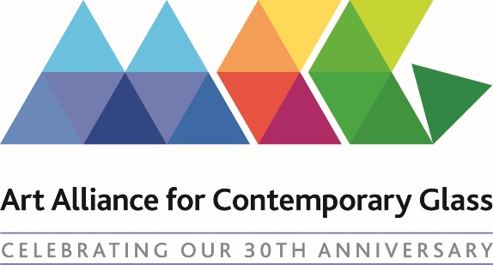

-END-

Media Contact: Huntington Beach Art Center
Jennifer Minasian, Arts Marketing Coordinator
jennifer.minasian@surfcity-hb.org | (714) 374-1657

Related Exhibition Events:

Public Reception: Sept 22, 2018 | 6:30–9pm

The Huntington Beach Art Center is proud to present the third exhibition in its series “The Power of Pigment: A Celebration of Color.” Shines Through explores contemporary glass works featuring 33 established and emerging glass artists. Curated by Hiromi Takizawa, the exhibition includes 2D, 3D, and installations works.

Art for Lunch: Oct 4, 2018 | 11:30am–1:30pm

Art for Lunch is a free event, open to the community. Patrons can enjoy their lunch in the galleries while enjoying the current exhibition Shines Through explores contemporary glass works featuring 33 established and emerging glass artists. Curated by Hiromi Takizawa, the exhibition includes 2D, 3D, and installations works. Dessert and beverages will be provided.

Film Screening: Chihuly in the Hotshop: Oct 11, 2018 | 6:30–8:30pm

Join the Huntington Beach Art Center for the film screening of Chihuly in the Hotshop! Internationally renowned glass blower Dale Chihuly thrives on chaos. Follow the documentary filmmaker Peter West as he follows the artist during a week-long residency at the Museum of Glass in Tacoma, Washington, and experience Chihuly's unique approach to his craft. Admission by donation. Snacks and refreshments will be provided.

Surf City Arts Fest: Oct 14, 20181 | 11am–4pm

The Huntington Beach Art Center is excited to present the Surf City Arts Fest. This event combines Family Arts Day and Art in the Park to bring to downtown Huntington Beach the largest outdoor celebration of the arts ever presented in Surf City! The festival will offer 75 booths for artists, an intergenerational art experience with unique hands-on art projects, food and beverage vendors, and live music and dance performance entertainment.

Poetry at the Center: Sept 27 and Oct 25, 2018 | 6:30–8pm

Please join the art center for a night of art and poetry! ​Snacks and refreshments will be provided.

Huntington Beach Art Center Information
Gallery Hours
T-Th: 12 – 8 pm | Fr: 12 – 6 pm | Sat: 12 – 5 pm
Closed Sun, Mon & most holidays.

538 Main Street | Huntington Beach, CA 92648
(714) 374-1650 | artcenterstaff@surfcity-hb.org
http://www.huntingtonbeachartcenter.org/

