FOR IMMEDIATE RELEASE:
September 3, 2019

Huntington Beach Art Center Presents The Edge of Light: Historic and Contemporary Perspectives on California Abstraction

Curated by Peter Blake
September 21 – October 26, 2019

Huntington Beach, CA – THE EDGE OF LIGHT: Historic and Contemporary Perspectives on California Abstraction, curated by Peter Blake, is a survey of California Abstraction from the late-Sixties to the present.
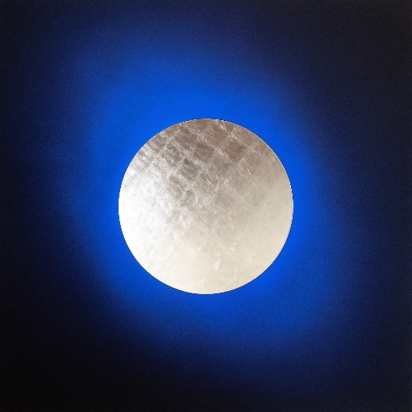
The mesmerizing history of abstraction in California art is often investigated in terms of landscape and geography, with varying attention granted to the influence of national trends. Over time, the groupings and subgroupings of California art formed by these inquiries have established an almost taxonomical classification for California Abstraction.

The Edge of Light revisits these inquiries while maintaining focus on the significance of Southern California’s unique region on the art. By including both historical and contemporary perspectives on California Abstraction, however, the survey seeks to curb the impulse for traditional categorizations of the individual practices.
Lita Albuquerque, Bleu Celeste (2018), 12K Gold Leaf on Resin, Pigment on Panel, 60 x 60 inches

As an intergenerational survey of California art, The Edge of Light engages with the major genres of California Abstraction, while also looking to disrupt traditional typologies. The exhibition invites us to consider the concepts brought into focus when we regard Hadi Tabatabai’s thread paintings as fixtures of the next generation of Hard-Edge Painting. It invites us to observe how the particulars of Gisela Colon and Phillip K. Smith’s respective works converse with rarely seen, historic Light and Space works temporarily on loan from private collections. Taken as a collection, these process-oriented works can be studied under the lenses of phenomenology, materiality, and ecology perspectives.

The survey of works presented for The Edge of Light reimagines the boundaries of traditional California Abstraction. With many important California artists receiving long-overdue recognition for their influential practices in recent years, The Edge of Light encourages us to redefine what exactly we are looking back on and how far back we can and should look.

The Edge of Light opens at the Huntington Beach Art Center on September 21. The exhibition features both historic and contemporary artists, including Lita Albuquerque, Peter Alexander, Charles Arnoldi, Stephanie Bachiero, Larry Bell, Gisela Colon, Mary Corse, Laddie John Dill, Joe Goode, James Hayward, Scot Heywood, Robert Irwin, Craig Kauffman, John McCracken, John M. Miller, Ed Moses, Helen Pashgian, Phillip K. Smith, Cole Sternberg, Hadi Tabatabai, De Wain Valentine, and Brian Wills.

The public opening reception is Saturday, September 28, 6:30 – 9pm. The Huntington Beach Art Center hosts free events throughout the calendar year for the public and HBAC members and patrons. On Thursday, October 17, curator Peter Blake will tour the exhibition with guests during the popular Art for Lunch series at the Art Center. The Huntington Beach Art Center Foundation invites the public to have their lunch at the Art Center and learn more about the current exhibition. Complimentary drinks and desserts provided courtesy of the Huntington Beach Art Center Artist Council.

-END-

Media Contacts: Huntington Beach Art Center
Kate Hoffman, Executive Director
khoffman@surfcity-hb.org | (714) 374-1658

Peter Blake Gallery
Genevieve Williams
genevieve@peterblakegallery.com | (949) 584-1224

Curator
Peter Blake
Exhibition Events
The Edge of Light: Historic and Contemporary Perspectives on California Abstraction
Curated by Peter Blake
Exhibition: September 21 – October 26
Members & Patrons Reception: Saturday September 28, 5:30-6:30pm
Public Opening Reception: Saturday September 28, 6:30-9pm
Art for Lunch: Thursday October 17, 11:30am-1:30pm
Film Night: Kusama Infinity (2018): Friday October 24, 6:30-8:30pm
Surf City Arts Fest: Sunday October 13, 11am-4pm

Huntington Beach Art Center Information
Gallery Hours
T-Th: 12-8PM | Fr: 12-6PM | Sat: 12-5PM
Closed Sun, Mon & most holidays.

538 Main Street | Huntington Beach, CA 92648
(714) 374-1650 | artcenterstaff@surfcity-hb.org
http://www.huntingtonbeachartcenter.org

